**Year 6 2020 Leavers Hoodies**

Dear parents and carers,

The Friends of Worth Valley Primary School have kindly offered to provide the class of 2020 with leavers hoodies.

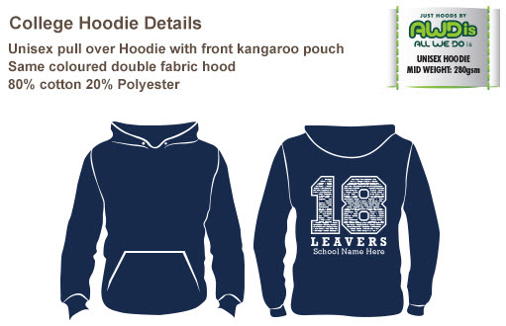

(It will say 20 leavers on this year’s hoodies)



Navy Blue

Burgundy

Charcoal Grey

If your child would like a hoodie, please let us know the colour and size. You can do this in 3 different ways:

* Phone the school office on 01535 604240
* Email Mrs Dobson directly at [r.dobson@worthvalleyprimary.co.uk](mailto:r.dobson@worthvalleyprimary.co.uk)
* Comment on the Facebook post this letter is uploaded to

Please make sure you reply no later than Friday, 29 May 2020 as the order will need to be placed to ensure they arrive in school before the end of the Summer term.

If we do not hear from you, we will assume you do not want one.

**Size Charts**

|  |  |  |  |  |  |  |  |
| --- | --- | --- | --- | --- | --- | --- | --- |
| **SIZE ADULT** | **½ Chest** | **Body Length** | **Sleeve Length** | **SIZE JUNIOR** | **½ Chest** | **Body Length** | **Sleeve Length** |
| XS | 49cm | 64cm | 57.5cm | 7/8yrs | 43cm | 52cm | 43cm |
| S | 51cm | 67cm | 59cm | 9/11yrs | 46cm | 57cm | 43cm |
| M | 56cm | 70cm | 60.5cm | 12/13yrs | 49cm | 62cm | 51cm |
| L | 61cm | 73cm | 62cm |  |  |  |  |

The jumpers will have the childrens’ names printed on the back; if you do not want your child’s name to appear on the jumper please tell us.

**Colour choice**

Charcoal

Burgundy

Navy Blue

**Size Choice**

***Junior***

7/8

9/11

12/13

***Adult***

Small

X. Small

Med

Large