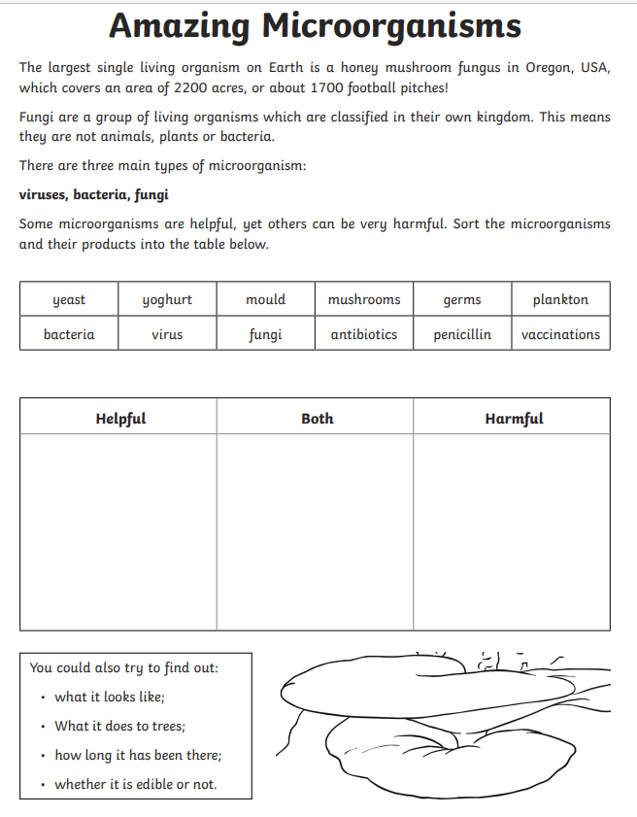
201020
Watch the powerpoint on Micro-organisms, then complete the sheet below.

