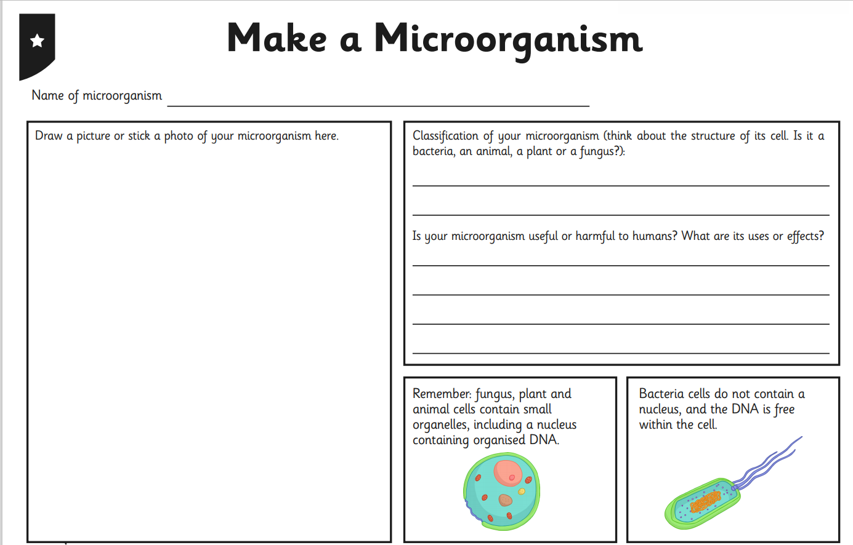
221020 Can you create your own microorganism?

