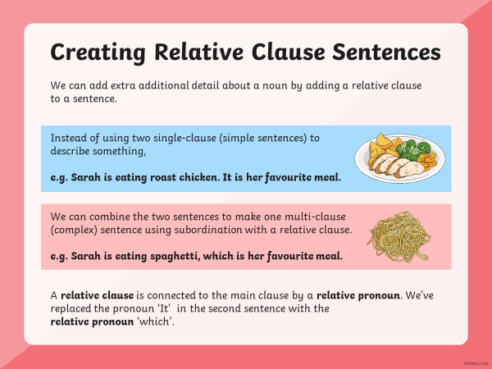
Day two

Can you add a relative clause to these sentences?

Add where who whose which

For example The teacher, who had curly hair, worked at Worth Valley Primary.
- My teacher told me to try my best.

- The boy ran down the street.

- I saw the dog.

- “Don’t cry”, said the girl.

- The athlete won the race.

- She lived in a small house.

- The girl clambered over the rocks.

- The wind battered the ships on the coastline.

- The island was a haven of peace.

- I live in Birmingham.

- Great Britain is a small island.

- The sofa was extremely comfortable.

Write about the pictures using relative clauses.

Day three

Complete tasks on powerpoint

