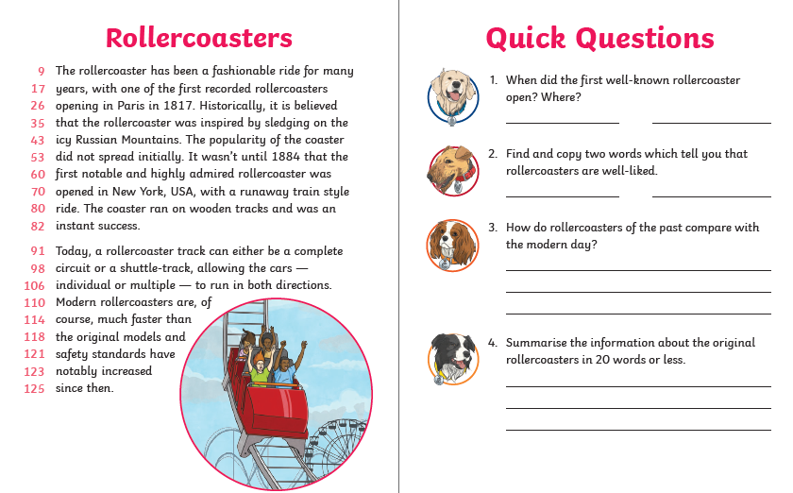
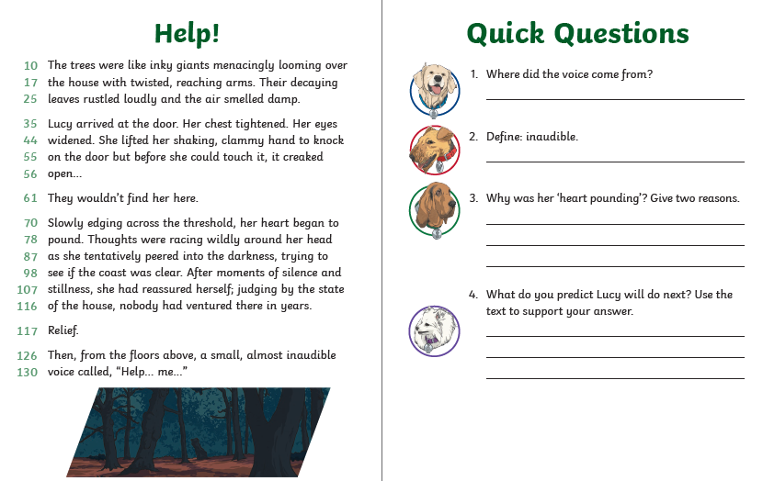
Day three - Thursday
Day four – Friday
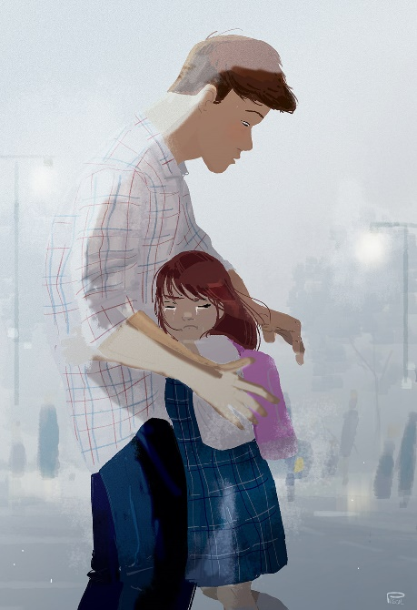
- How is the girl feeling? How do you know?
- Why is she feeling that way?
- Who is the man?
- Where are they?
- Does the title give you any clues about this image?
- What are the characters thinking? Draw thought bubbles to accompany the picture.

