Group 1 spellings – Wk beginning 19.10.20

In a nutshell
The /ai/ sound can be spelled in a variety of ways: ‘ai’ (rain), ‘ay’ (day), ‘ea’ (great), ‘a_e’ (brave), ‘a’ (baby), ‘ei’ (beige), ‘ey’ (grey) and ‘eigh’ (weight). The focus spelling patterns for this unit are ‘ei’, ‘eigh’ and ‘ey’.
Word list
they grey obey beige sleigh neigh neighbour eight eighth weight reins reign vein veil height

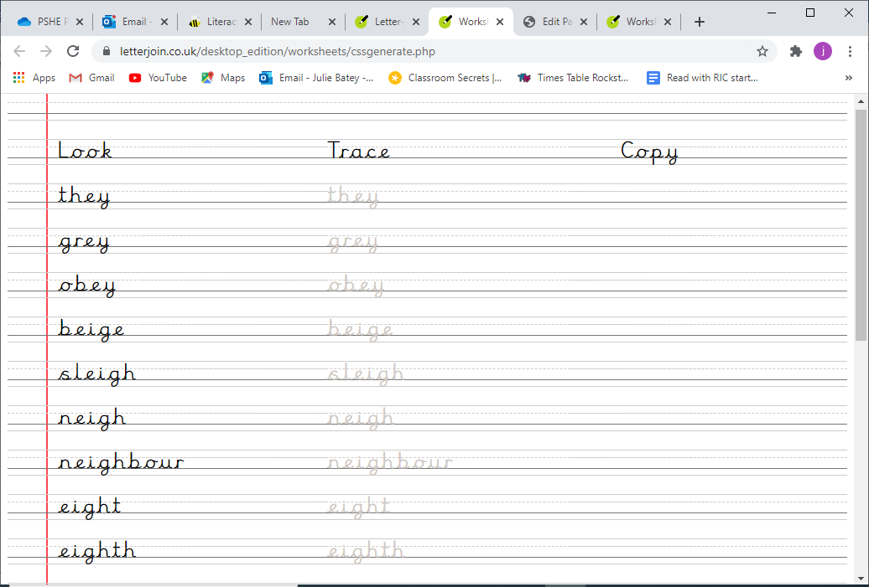

Write the ai sound spelt ei, ey, or eigh
- My next door ________________knocked at the door.
- Tomorrow, I will be ________________ years old.
- Santa Claus rides on a ___________________ with several ______________________.
- My coat is a _________________ colour.
- I can hear a horse _________________ in the distance.
- I did a ________________ in school of everyone’s favourite vegetables; carrots got the most votes.
- When riding a horse, hold the _____________ tight.
- I must _______________ the rules when in school.
- To win the cake you must guess the ______________ of it (in grams).
- The country is under the King’s ________________.
- One multiple of ______________ is 36.

Write a short paragraph below using as many of the words from today’s spelling rule as you can!

