Group 3 spellings – Wk beginning 19.10.20

In a nutshell
When the ‘ow’ precedes an ‘n’ or ‘l’ it is usually spelled ‘ow’, e.g. town, owl.
Word list
now howl out sound how growl about aloud brown prowl mouth round
down cow around town clown owl crown vow

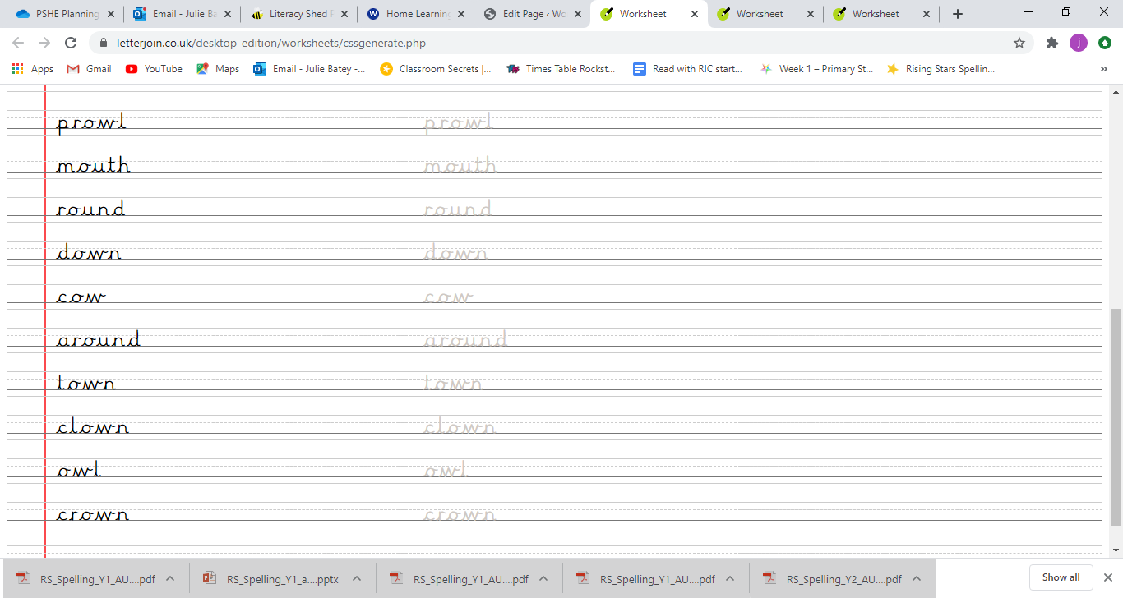
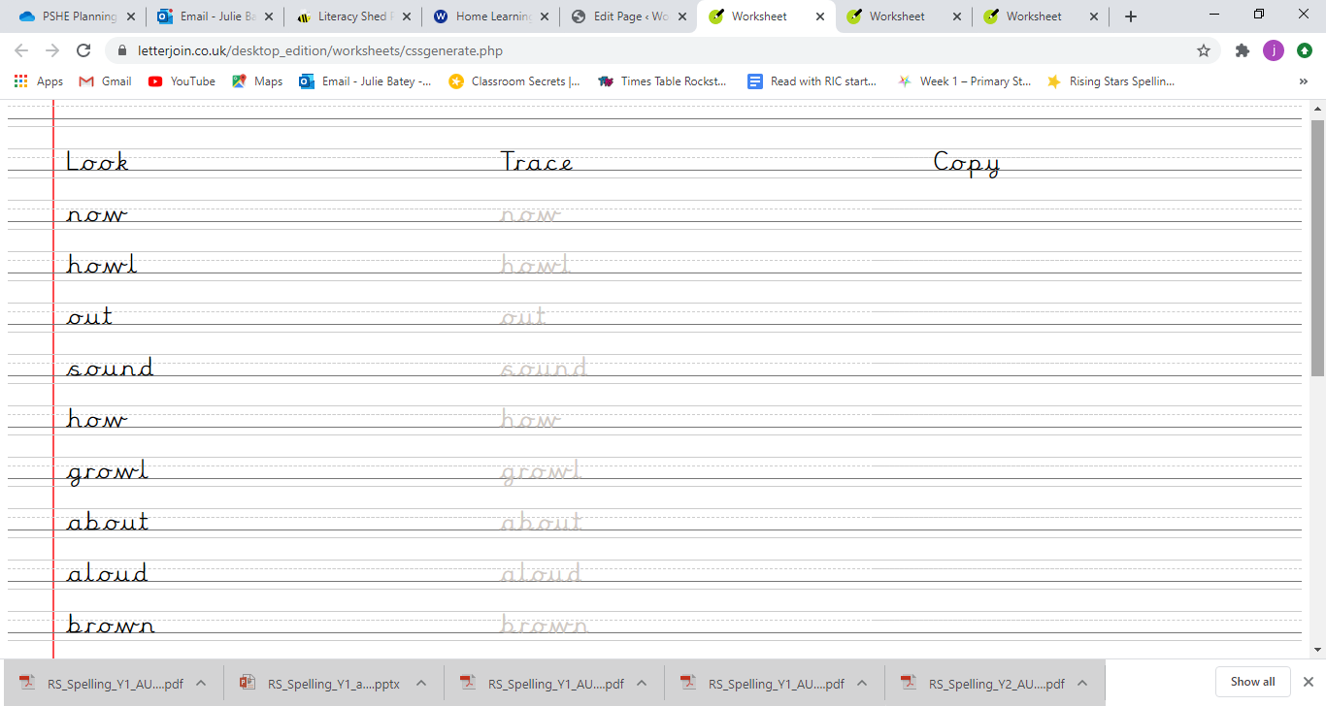

Write the word to match the picture

