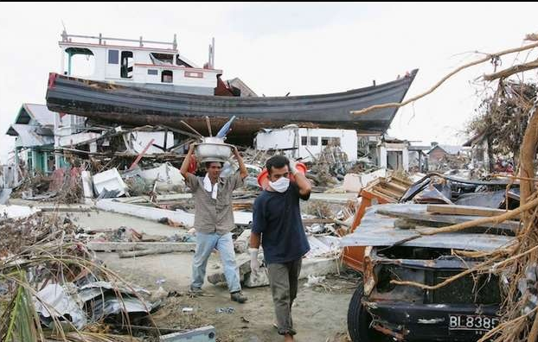
Reading day one

Literal Questions:
What is the ship on top of? __________________________________________
_____________________________________________________________________
What is in the bottom right corner? ___________________________________
_____________________________________________________________________
What do the people wear? __________________________________________
_____________________________________________________________________
Inference Questions:
What happened here? _______________________________________________
_____________________________________________________________________
Why is the ship where it is? ________________________________________ ____________________________________________________________________
What are the people doing? __________________________________________
_____________________________________________________________________
Where are the people from the ship? __________________________________ _____________________________________________________________________

