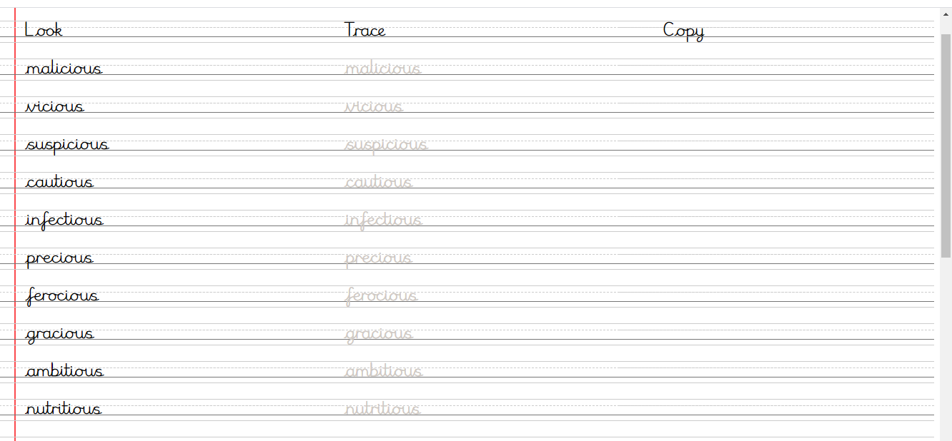
Day 1
Day 2
Day 3
space |  | caution
vice |  | ambition
malice |  | infection
suspicion |  | nutrition
Write the words with their endings – the /shus/ sound.

Day 4
Write a sentence for each of the following words:
malicious vicious
precious suspicious
infectious cautious
ferocious ambitious

