Day one
he he he he he he he he he

she she she she she she she

I I I I I I I I I I I I I

Day two

be be be be be be be be be

do do do do do do do do do

am am am am am am am am

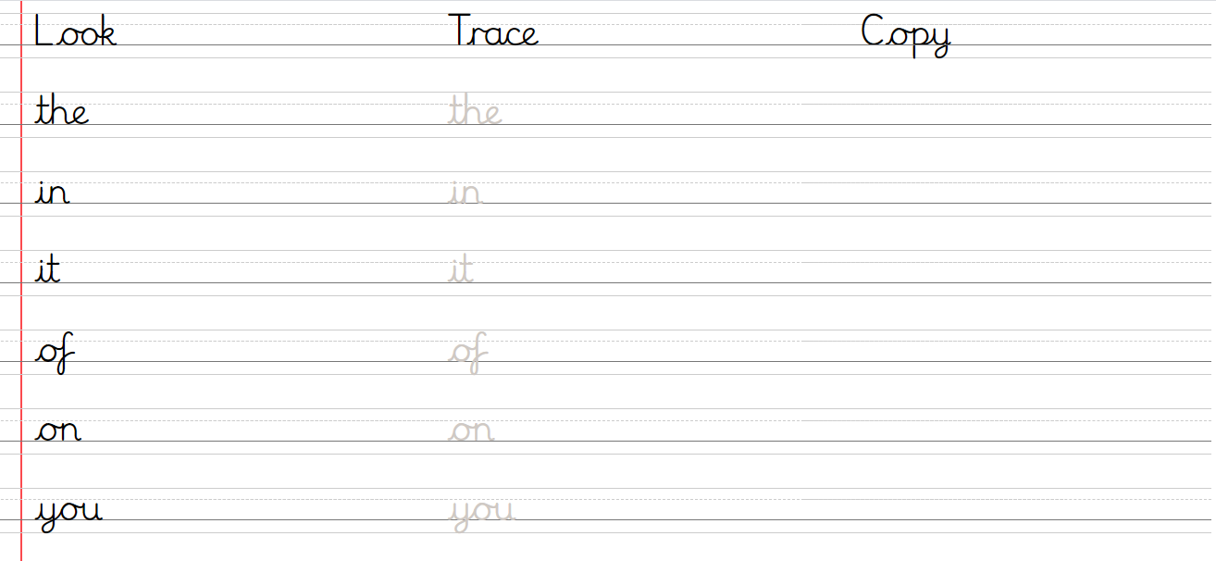
Day three and four

