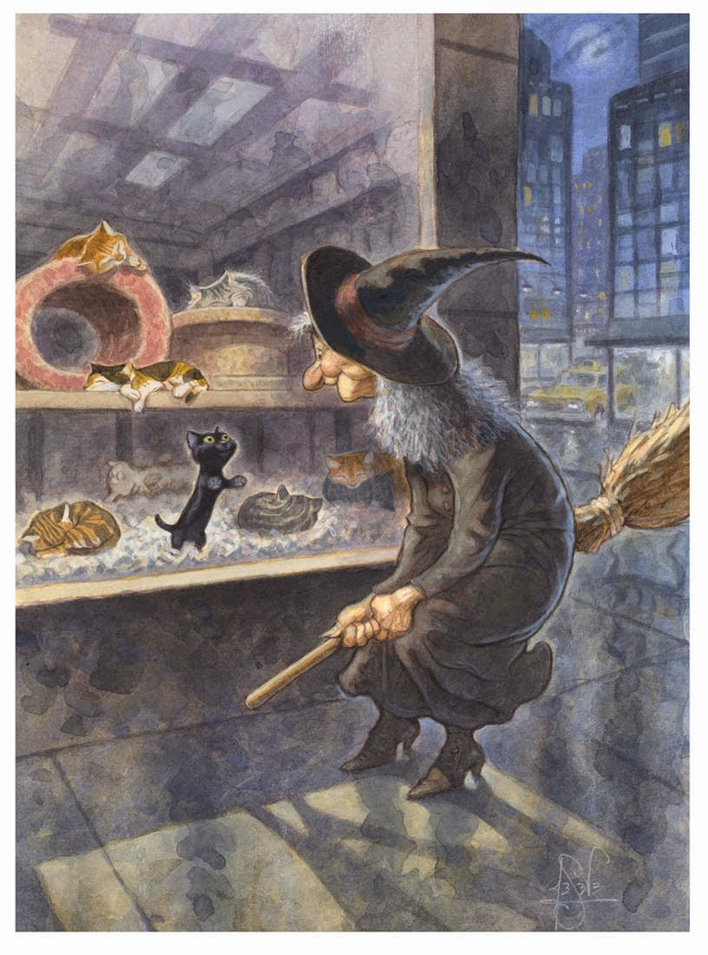
  - Why is the black cat the only cat looking at the witch?

- Why did the witch come here? Was she just passing or did she come to the shop for a reason?

- What is the ‘something familiar’? Why?

- Do the witch and the cat already know each other?

- What do you think is going to happen?

