Reading extract and questions:

A Prickly Problem
Set A/B

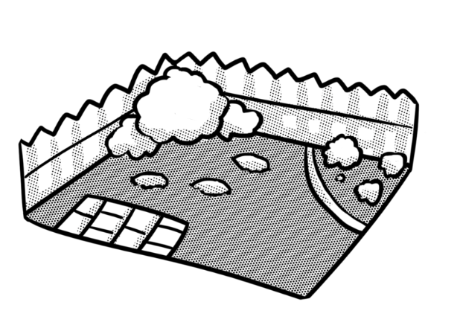
Straight after tea, Jonjo ran out into the garden. After a few minutes, he shivered and ran back inside. He found his coat and pulled on his wellies, taking care to tuck his new school shoes out of sight so that they could dry without Dad noticing.
“Give us a hand,” said Dad, who had been raking leaves. He had found a large, old cardboard box and was stuffing crunchy brown leaves into it. Together, they filled the box in no time. Before it got too dark, they tucked the box down the side of the house and covered it with an old plastic sack. “At least we’ll have something dry to burn on bonfire night,” said Dad.
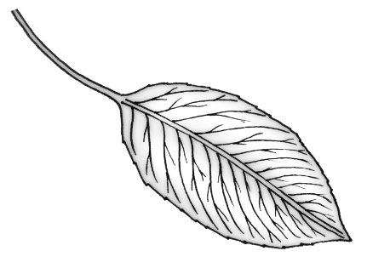
A few weeks later, they were back in the garden. Dad had cleared a safe space for a bonfire and was gathering twigs and old wood. He brought the box over then went inside to get the matches and some paper. There was a strange noise. Jonjo listened. There it was again! It was a sort of scratching sound. Then it stopped.
Dad came back and scrunched up the paper. The plan was to get the fire going, then tip the dried leaves on top and place bigger sticks around it. “Soon,” said Dad, “we’ll have as good a bonfire as any in the park. We won’t have to pay to see it, neither.”
Jonjo sat by the box a safe distance away while Dad lit the paper. An orange flame flickered into life. Twigs crackled as they caught fire too. There it was again! The scratching noise!
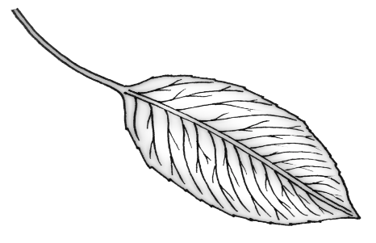
“Stop! Wait!” cried Jonjo as Dad reached for the box. He grabbed it and tipped it upside down on the grass. A spiky little ball rolled out. “Just in the nick of time!” gasped Johjo as Dad put on his gardening gloves and gently picked up the hedgehog. Soon, the little creature was safely placed under a bush, well away from the fire.
“I know they like to find somewhere warm and dry to sleep all winter, but I think that would have been a bit too warm!” grinned Dad.

Questions for
A Prickly Problem
Set A
Vocabulary
1. Look at the paragraph beginning “Give us a hand,’ …. Find and copy a word that means scraping up.

_________________________________________________________________

2. … in no time … This means … Tick one.

we’re late we have to go back in

the clock had stopped very quickly

3. … An orange flame flickered … In this sentence, flickered means … Tick one.

switched exploded

sparked burnt

Identify key aspects
4. When did Jonjo run into the garden?

_________________________________________________________________

5. What two things did Dad go inside to get?

- ___________________________________ b. ___________________________________

Inference
6. Why did Jonjo run back inside?

_________________________________________________________________

Sequence
7. Number the sections from 1 to 4 to show the order in which they appear.

Dad cleared a space for bonfire.
Jonjo tipped the box upside down.
Jonjo hid his school shoes.
Dad lit the bonfire.

Predict
8. What do you think Jonjo will say next year if they collect leaves in a box for a bonfire?

_______________________________________________________________________________
Questions for
A Prickly Problem
Set B
Vocabulary
1. Look at the first paragraph. Find and copy a word that means shook.

_________________________________________________________________

2. … “Give us a hand” … This means … Tick one.

“Pass me my glove,” “Stop!”

“Help me,” “Wave to me,”

Identify key aspects
3. Where did they leave the box of leaves?

_________________________________________________________________

4. What sort of sound did Jonjo hear?

_________________________________________________________________

5. Where did Dad put the hedgehog?

_________________________________________________________________

Inference
6. Why did Dad put on gardening gloves?

_________________________________________________________________

Sequence
7. Number the parts of the story from 1 to 4 to show the order in which they happened.

They covered the box with a plastic sack.
Dad put the hedgehog under a bush.
The twigs caught fire.
Jonjo put on his coat.

Predict
8. What would Dad say if he found Jonjo’s new school shoes before they dried out?

_______________________________________________________________________________

