Can I answer comprehension questions about a text?

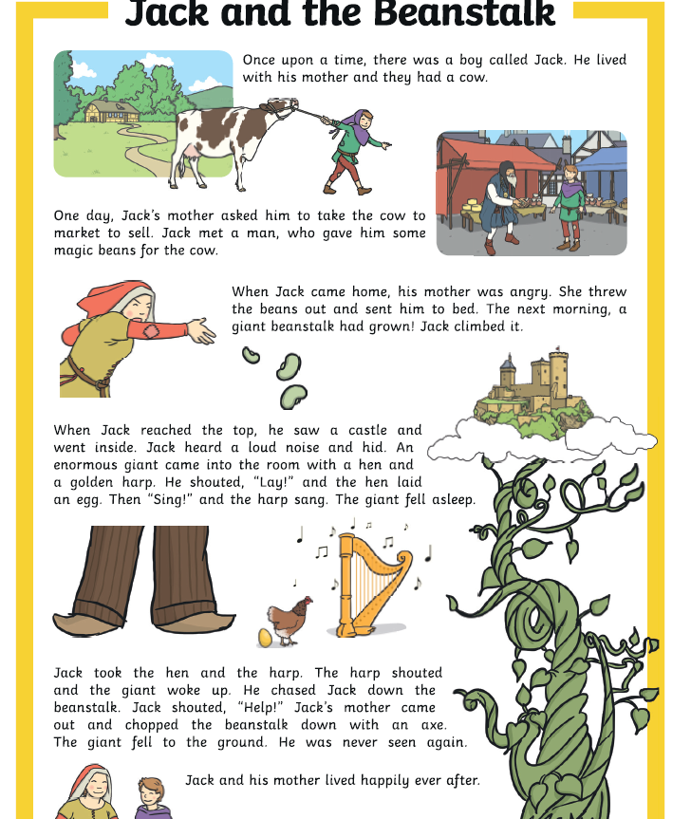

Questions:
- What was the boy called?
_____________________________________________________

- What animal did Jack and his mother have? ________________________________________________
- What did Jack get for the cow? _____________________________________________________
- How did Jack’s mother feel when Jack came home? _____________________________________________________
- What had grown the next morning? _______________________________________________________________________________________________________________________________________________________________
- Who came into the room? _______________________________________________________________________________________________________________________________________________________________
- What did the giant do after the harp sang? ____________________________________________________________________________________________________________________________________________________________________________________________________________________
- Where did the giant chase Jack? _______________________________________________________________________________________________________________________________________________________________

