Counting money.

When you count money check what each coin is **worth.** What are you going to count in?

** Counting in 1s. 1,2,3,4 = 4p**

**Counting in 2s. 2,4,6 =6p**

** Counting in 5s. 5,10,15 =15p**

** Counting in 10s. 10, 20 =20p**

** Counting in 20s. 20, 40, 60 = 60p**

**If counting in 20s is difficult count in 2s. 2, 4, 6. =6p**

**Look at what you know from counting in 2, that will help counting in 20s.**

**Now you have a go.**

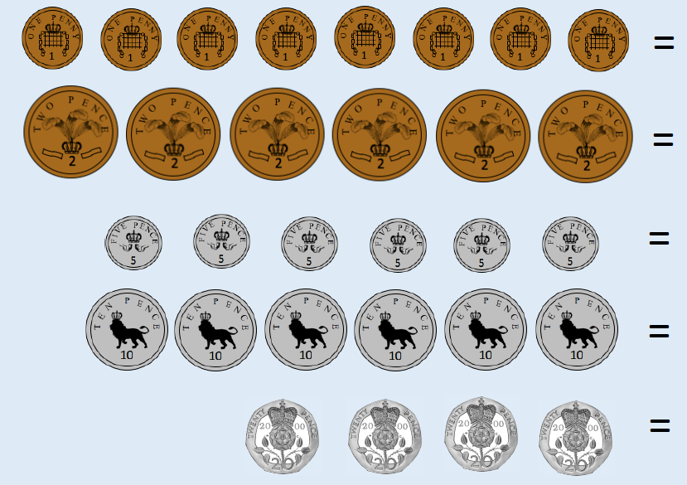 **Remember to add the correct value in pence eg 10p**

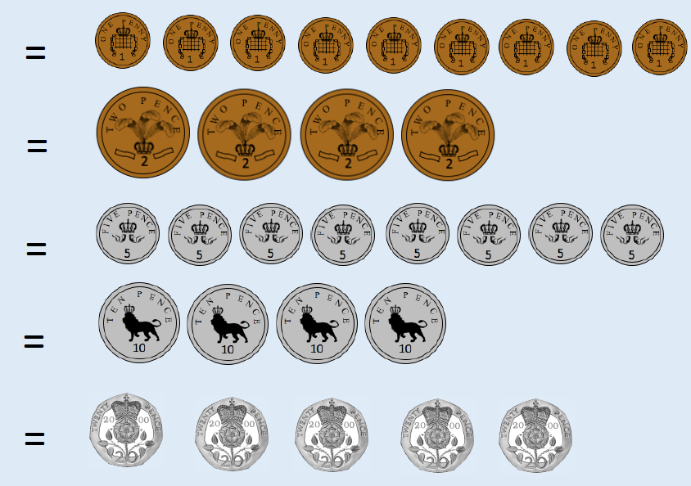

**Now for the answers!**

