Counting money.

When you count money check what each coin or note is **worth.** What are you going to count in?

** 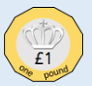 Counting in 1s. 1,2,3,4 = £4**

**Counting in 2s. 2,4,6 = £6**

** Counting in 5s. 5, 10, 15 = £15**

** Counting in 10s. 10, 20 = £20**



** Counting in 20s. 20, 40, 60 = £60**

**If counting in 20s is difficult count in 2s. 2, 4, 6. = 6**

**Look at what you know from counting in 2, that will help counting in 20s.**

**Now you have a go.**

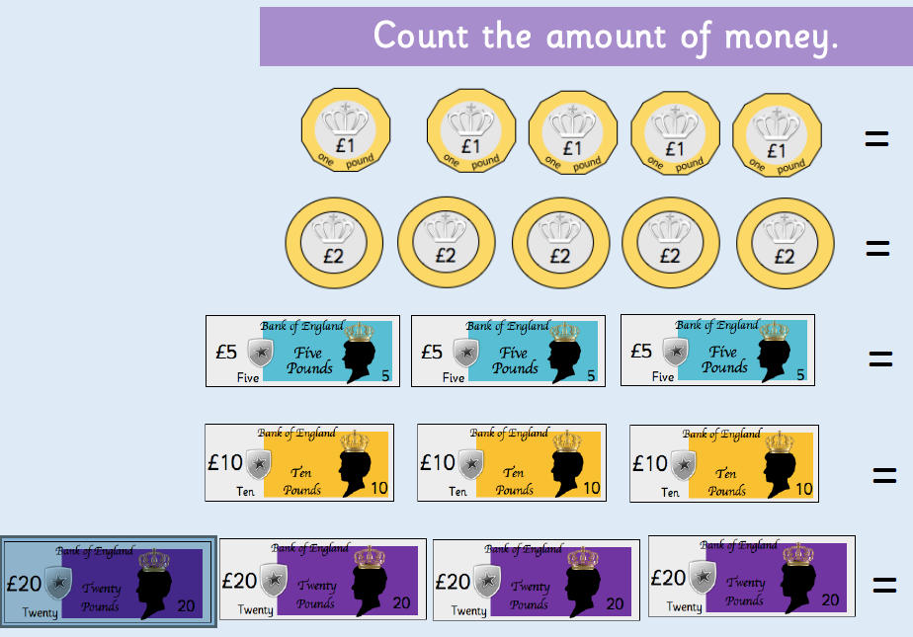 **Remember the £ sign goes in front of the number.**

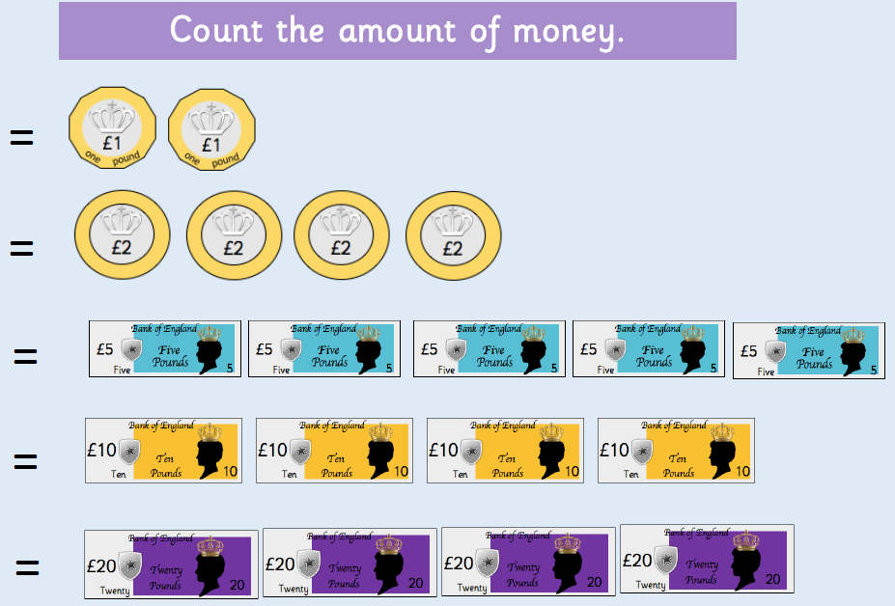

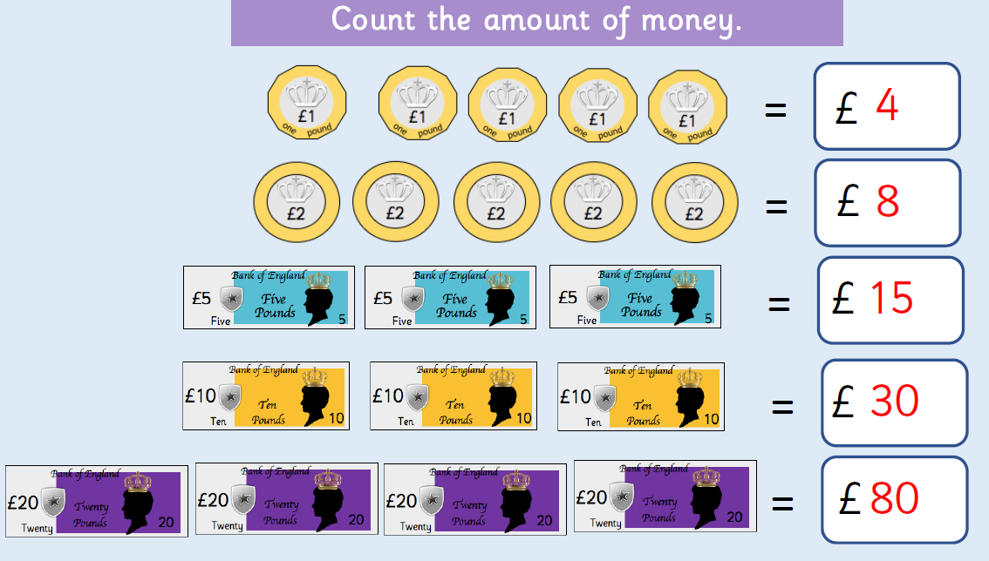**Now for the answers!**

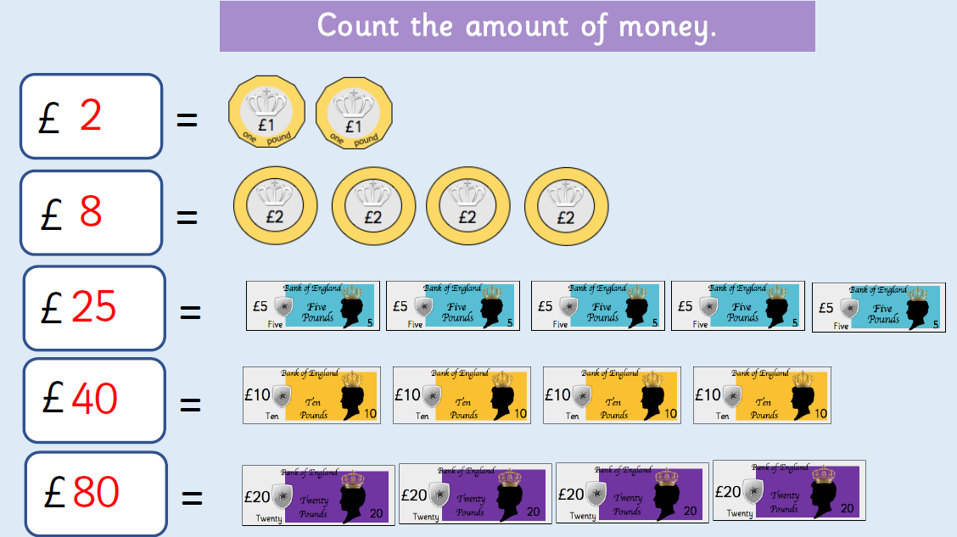

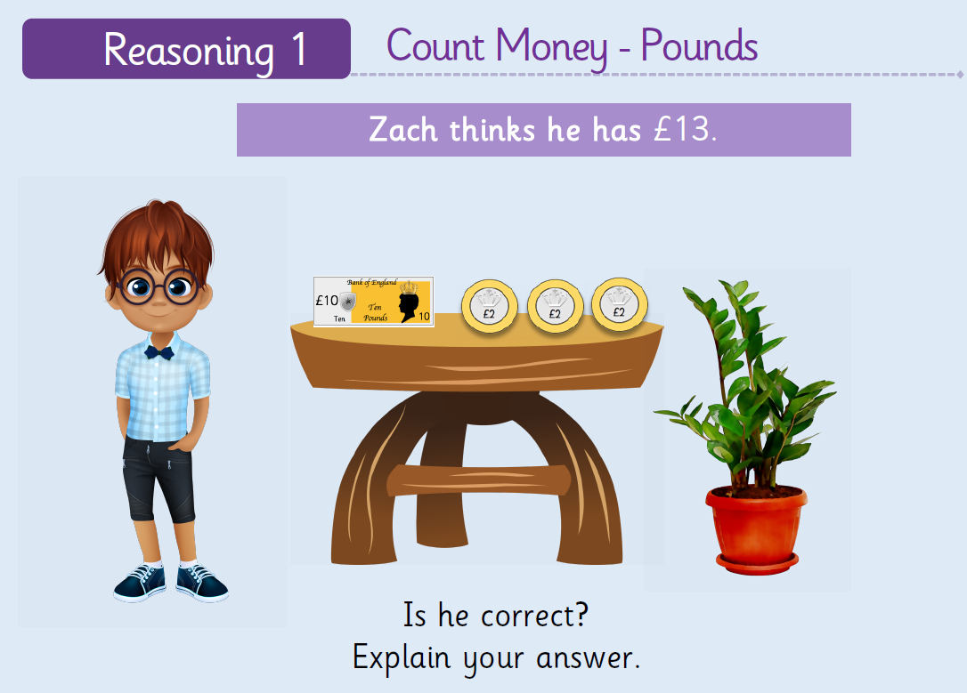**Go to the next page for the answers.**

