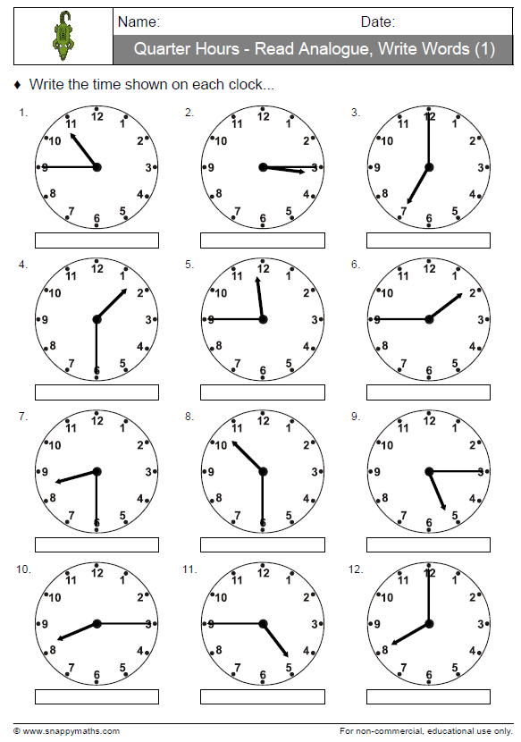

7 o’clock

Quarter past 3

Quarter to 11

Quarter to 2

Quarter to 12

Half past 1

Half past 10

Quarter past 5

8 o’clock

Half past 8

Quarter to 5

Quarter past 8