**Some questions to try.** Think back to the work we did before Christmas

You will need to write down your answers and working out on a piece of paper.

You could take a picture of your work to show me.

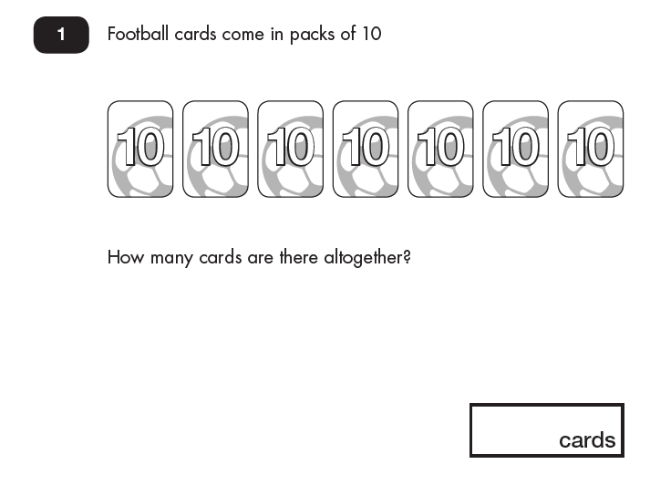

Tip – What are you going to count in?

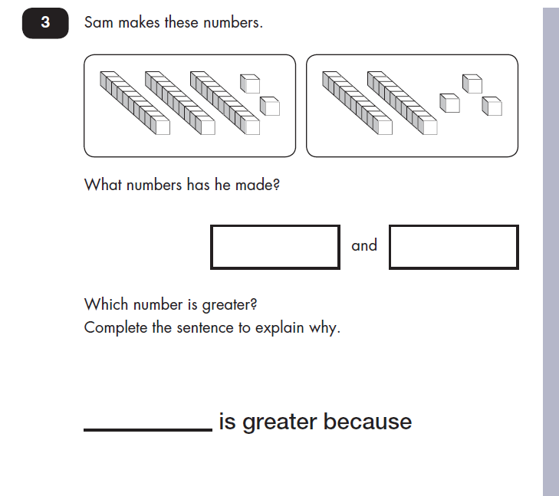

Think about the ten sticks and ones

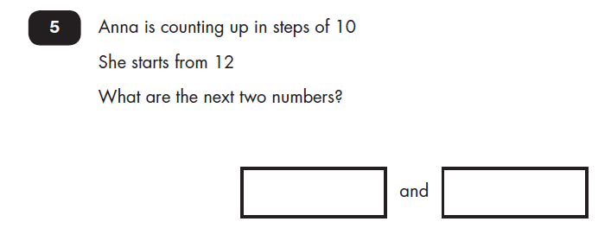

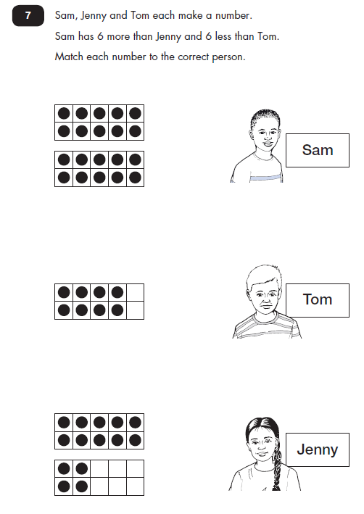

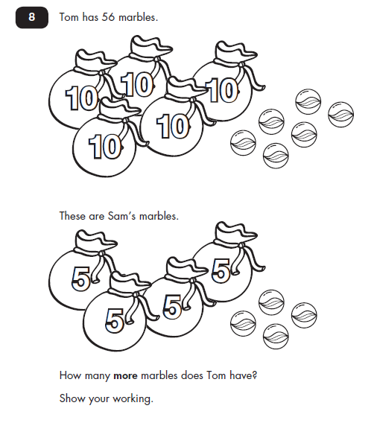

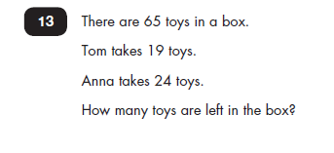

What calculation will you do first?

What comes next?