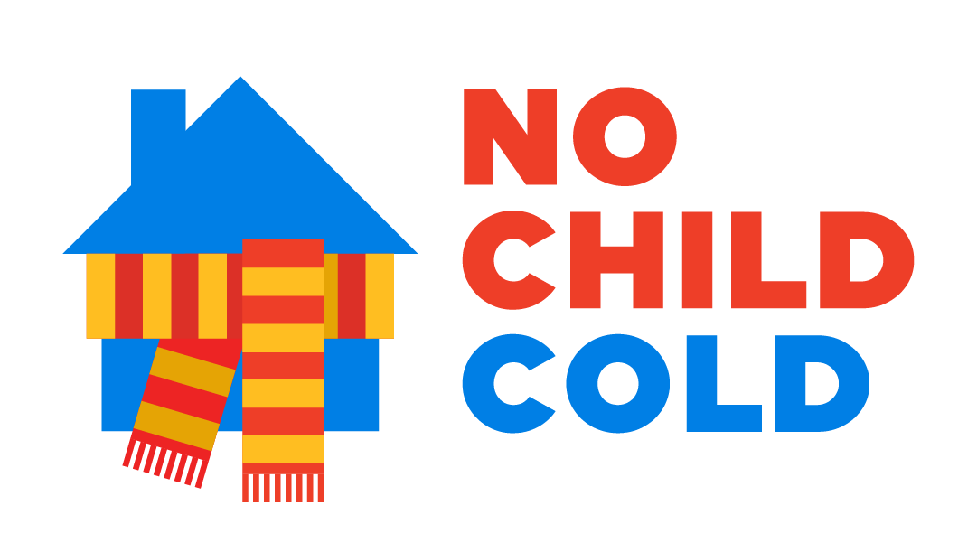
No Child Cold – helping our district’s children keep warm this winter
We have seen how the COVID -19 pandemic has presented many challenges for our district. A critical challenge we are facing right now is the need to keep children warm this winter.
As a result of the latest lockdown, 75,000 children in our district are currently at home all day, every day at a time of year when temperatures are regularly below freezing. At least 21,000 children in our district live in homes where the pressures of the pandemic mean that families are struggling to afford to heat their homes for this extra time.
No Child Cold is a campaign to raise money to provide direct help to these families. It has been set up by Bradford partners to make sure that no child in the Bradford District is left in the cold this winter as a result of lockdown. Those partners include Citizens Advice. Bradford Council, along with faith and community organsiations and businesses in our district.
Main Landing Page
As our districts’ children sit down at home to access remote learning, we want to make sure no child is unable to learn, because they are simply too cold.
Our vision is to make sure no child slips through the gaps and is left feeling more of the winter chill than is safe for them.
This scheme is raising funds from the kindness and generosity of businesses, organisations and individuals across the district. This money will be used to give small grants to our district’s families who have higher fuel bills because children are at home instead of at school, and who might not otherwise be able to pay their fuel bill.
You can support this project quickly and simply through our Give Bradford page, and help children in need across our district keep warm during this lockdown. Any donation is welcome and will make a difference in helping to keep children warm.
Please join the many business, organisations, faith groups and individuals who have already pledged to support No Child Cold.
You can also apply for help from the scheme if you need it, and find out about other support that is available.

How the scheme works
The scheme is being run by Citizens Advice, and will take referrals from schools and the voluntary sector.
No Child Cold will support people with school-aged children aged 4 to 18 in the household who are receiving education at home during the winter period as a result of COVID-19 school closures. They will receive a grant which will help cover the additional fuel costs incurred to heat the home when children would usually be in school. Recipients will live in a household where at least one of the following applies:
How it works Page
- household income, of those responsible for bills, has fallen due to a reduction in wages, either because of a reduction in working hours, a loss of regular overtime or a member of the household has been furloughed.
- The family is a low-income household (defined as being in receipt of UC, tax credits or other income related DWP / local authority benefit) and fuel costs have increased as a result of children being at home because of school closures.
- The family live in a household where the child would be entitled to free school meals and fuel costs have increased because the children have had to stay at home because of school closures.
The maximum grant value for families will be £80.00. This can be split between gas and electricity payments or bills. This is a one-off payment to households. Only one application is permitted, per household, between the scheme’s launch in January 2021 and its closure on 31 March 2021.

Give Bradford
The partnership’s charitable administration is being managed by GiveBradford, which is part of the Leeds Community Foundation, registered charity number 1096892.
Initially donations given will go to organisations supporting people experiencing fuel poverty to help them access support and pay their bills, but this focus may change over time to make sure the money you give is going to where it can make the most difference in response to the COVID-19 crisis.
I really do hope that you can help us support this campaign. Together we can make a difference.

No Child Cold is a Bradford District partnership which includes:
- Bradford Cathedral
- Bradford Chamber of Commerce
- Bradford Council
- Bradford District Care Trust
- CABAD (Community Action Bradford & District)
- Give Bradford
- Incommunities
- Race Equality Network
- The Cellar Trust
- Yorkshire Building Society
- The Telegraph & Argus

