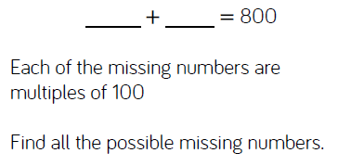
Rewind
63 = 53 + ?
630 = 1000 - ?
2068 = ? + 420
? = 9371 - 556

