Rising stars spelling. Can I spell words with the r sound spelled as wr?
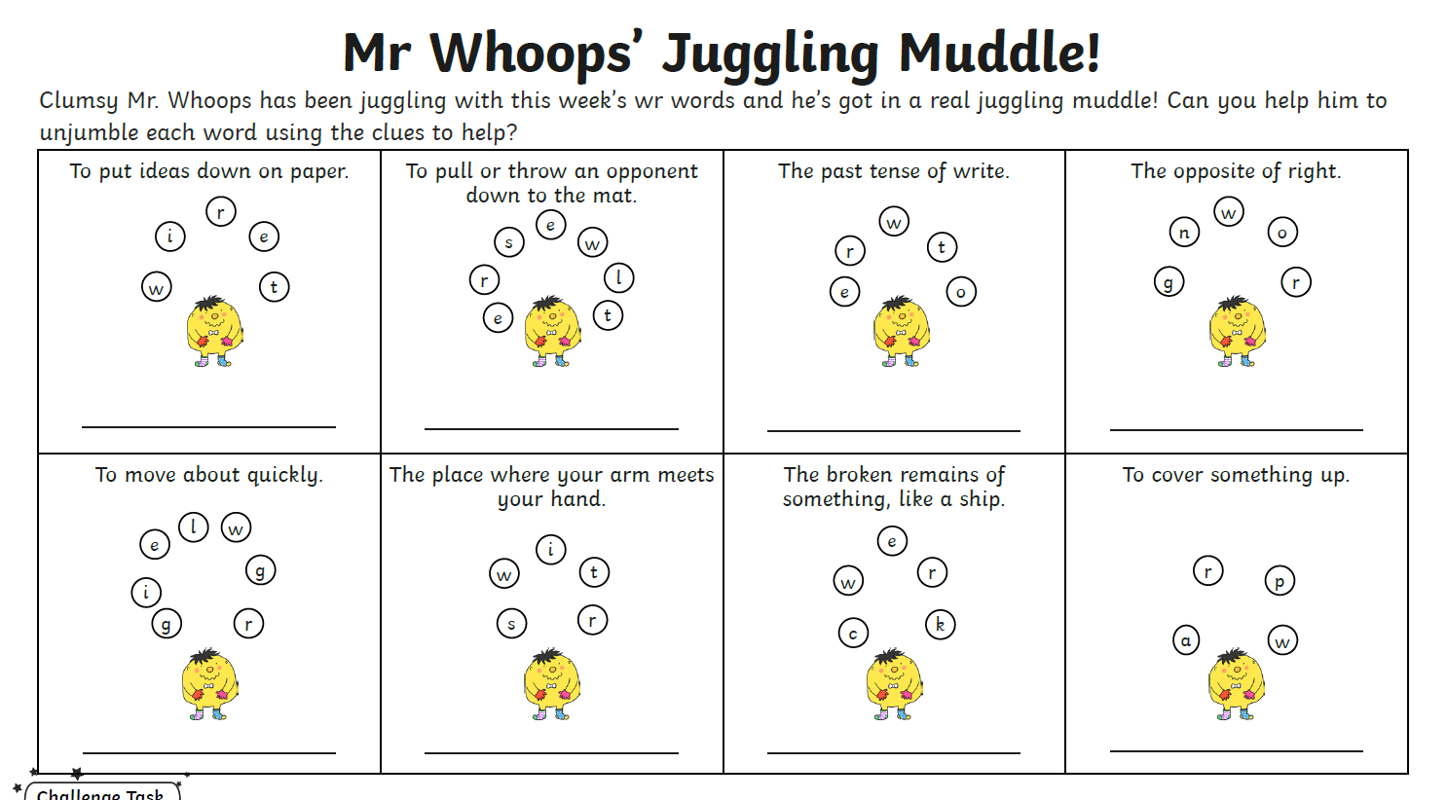

Can you check your answers are correct using the answer sheet? Are your spellings correct?

