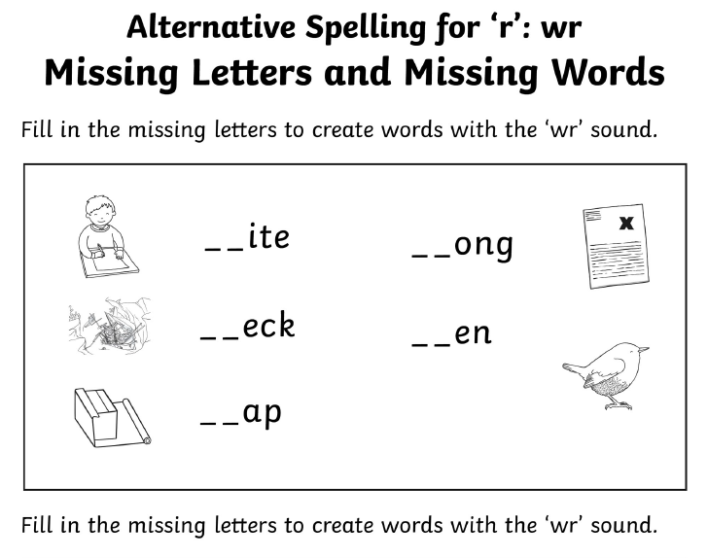
The ____________________ is making its nest.

George must ___________________ his presents before Christmas.

I hope I don’t get too many answers ________________ in the quiz.

Ben likes to ________________ stories about superheroes.

“Let’s swim down and look at the ship ___________” said Kim.

