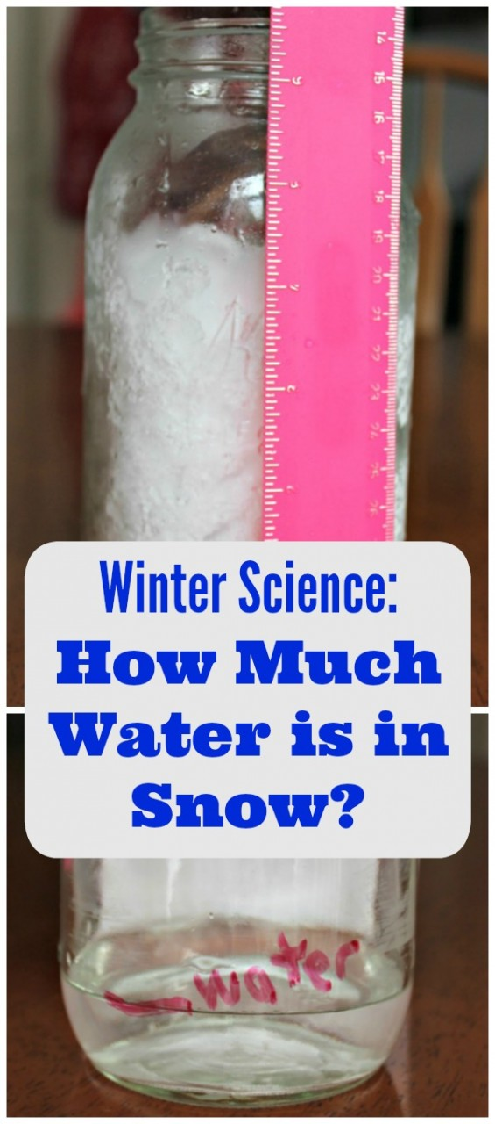
While watching a weather forecast on day I was told that 13cm of snow melts to 1cm of water.
Squirrels we have the ideal conditions to test this statement, are they correct?
Take a jar or bottle and fill it to 13 cm with snow (you need to pack it down so that it is really full. Now let it melt (don’t put it on a radiator).
How many cm of water do you have? Send me pictures of your experiment and your results.
Do you know why snow shrinks when it melts?

