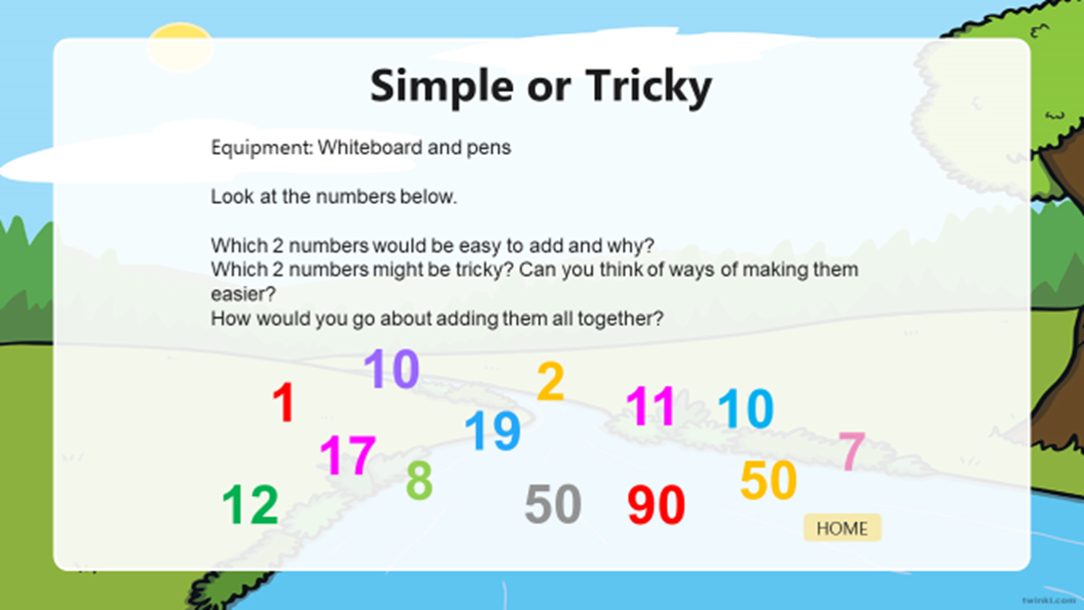

Type your answers under here. Remember to write in sentences.

