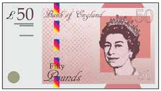
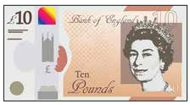
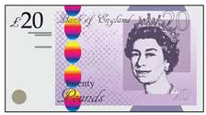
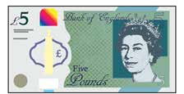
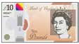
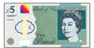
Recognising notes

Match the note to its value.
1

5 pounds

20 pounds

10 pounds

50 pounds

Dan has two £10 notes and one £5 note. Circle the notes that Dan has.
2

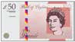
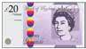
Here are some notes.
3

Complete the sentences.

There are £5 notes.

There are £10 notes.

There are £20 notes.

There are £50 notes.

Tick the note with the smaller value.
4

a) 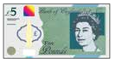 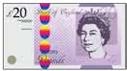
b) 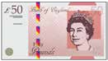 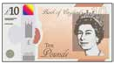

c)

