**Dragon school**

Would you like to be the best dragon you can be?

Why not join dragon school? There are so many fun things to do & you can become the best dragon ever!

Please email us for an application form.

Dragon123@fire.com

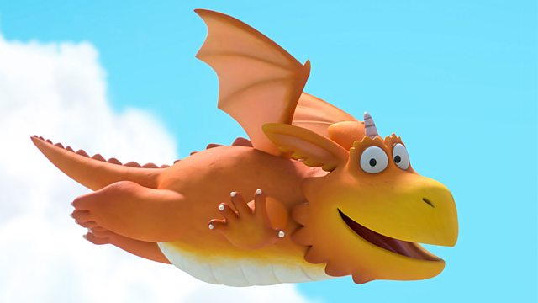

You can learn to fly high in the sky in and out of the fluffy clouds.

You can learn to roar as loud as can be, the leaves will fall from the trees.

You can learn to breathe red hot fire!