24.02.21
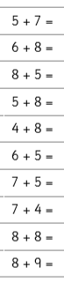
LO – Solve addition questions.

