Zog Tasks
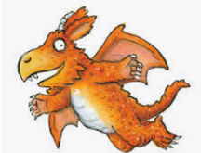
How many of these tasks can you complete? Remember to send me pictures of your work:
s.hiley@worthvalleyprimary.co.uk

Can you draw or paint a picture of Zog? | Can you make a model of Zog?  (You could use playdough or any junk modelling things such as boxes, toilet roll tubes etc. | Can you build a castle for Princess Pearl and Zog? (You might want to use Lego, building blocks or junk modelling things)
Can you make a certificate for Zog to go with his golden star? | Can you write instructions to teach Zog how to fly? | Can you write a list of all the rhyming words you can hear in the story?
Can you write instructions to teach the dragons to look after Sir Gadabout's horse? | Princess Pearl doesn't like silly frilly dresses. Can you design some new clothes that she might like? | Can you draw a map to show Zog’s route to school?

