Zog and The Flying Doctors Tasks
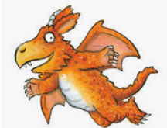
How many of these tasks can you complete? Remember to send me pictures of your work:
s.hiley@worthvalleyprimary.co.uk

Can you draw or paint a picture of Zog or Princess Pearl? | Can you make a model of Zog or Princess Pearl?  (You could use playdough or any junk modelling things such as boxes, toilet roll tubes etc.) | Can you build a castle for Princess Pearl and Zog? (You might want to use Lego, building blocks or junk modelling things)
Can you make a poster to show the Flying Doctor Service? | Can you create a new page for the book in which Pearl, Gadabout and Zog help a different patient? | Can you write a list of all the rhyming words you can hear in the story?
Can you create a map that shows the different places shown in the story? Add labels to show where the different events took place (e.g. Where was the mermaid wailing? Where was the lion’s cave?). | Princess Pearl doesn't like silly frilly dresses. Can you design some new clothes that she might like? | Can you make a leaflet or poster to teach people about how to stay healthy?

