8 June 2021
Dear parents and carers,
Summer Reading Challenge
This half term we are aiming to get our pupils reading at home as much as possible and we need your support!
There are 33 days until the end of the school year and we are encouraging pupils to read at home to an adult on as many occasions as possible in order to develop their reading fluency and decoding skills – starting today!
If a pupil reads at home on 20 separate occasions between now and Friday 16 July they will be awarded a character bookmark and bookworm pin badge;
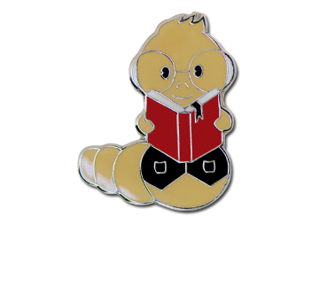
Furthermore, for every 5 times a child reads to an adult at home they will be issued a raffle ticket towards a family raffle - to be drawn on Monday 19 July
All you need to do is listen to your child read at home and sign their reading record. School staff will keep a record of the number of times your child has read at home. Please also note that the reading championship will continue to run alongside this incentive as normal. Thank you in advance for your support!
Yours sincerely

Miss Lodge
Headteacher

