Comments on the impact of organisational and presentational features of a text Test 1
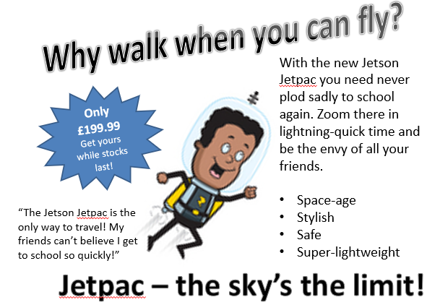

- What is the purpose of this text?

_____________________________________________________________________

- What are the organisational features of this text type and what effect do they have?

_____________________________________________________________________

_____________________________________________________________________

_____________________________________________________________________

- What are the presentational features of this text type and what effect do they have?

_____________________________________________________________________

_____________________________________________________________________

_____________________________________________________________________

