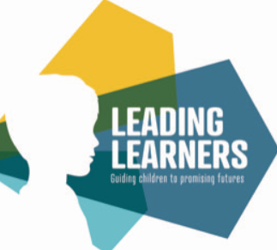
Leading Learners Academy Trust
Maths
Rationale
Mathematics is a creative and highly inter-connected discipline that has been developed over centuries, providing the solution to some of history’s most intriguing problems. It is essential to everyday life, critical to science, technology and engineering, and necessary for financial literacy and most forms of employment. A high-quality mathematics education therefore provides a foundation for understanding the world, the ability to reason mathematically, an appreciation of the beauty and power of mathematics, and a sense of enjoyment and curiosity about the subject. (DFE- Mathematics programmes of study: key stages 1 and 2 –National curriculum in England - September 2013).
Intent:
At Leading Learners Academy Trust, we believe that Maths is a fundamental corner stone of our curriculum and is designed to engage and captivate children whilst providing them with the mathematical skills that are needed for the next stage in their educational journey and for later life. We want our children to be confident mathematicians that are fluent, can reason and solve problems with a secure understanding across concrete, pictorial and abstract methods of maths. Our maths curriculum provides opportunities to connect, consolidate and reinforce maths skills whilst also developing fluency in both arithmetic and times tables to allow children to be able to access all areas of learning within mathematics. Key instant recall facts and concepts for each year group are carefully sequenced and mapped for each half term.
To ensure that all pupils reach their full potential, their individual needs and abilities are recognised and developed within a caring and supportive environment. This journey begins in Early Years and is achieved through providing stimulating practical investigations, real world projects, role play areas and problem solving across the curriculum to ensure the very best start to children’s understanding of mathematical concepts and development of mathematic skills. This fundamental start to a child’s mathematical journey enables all children to have access to a full curriculum as they move up throughout school which enables them to achieve confidence and competence or in other words, ‘mastery’, in maths. This mastery approach to mathematics means that pupils need to develop three forms of knowledge:
- Fluency (Factual) I know that…
- Problem Solving (Procedural) I know how…
- Reasoning (Conceptual) I know why…
When pupils are given opportunities to develop their fluency, problem solving and reasoning skills, they are able to develop a deeper understanding of mathematical concepts and become more proficient in their skills and application of mathematical knowledge.
Implementation
To meet our curriculum aims for maths, teachers will deliver lessons which are:
- coherently planned;
- sequenced to ensure cumulatively sufficient knowledge and skills for future learning.

The aims of the National Curriculum are to develop fluency and the ability to reason mathematically and solve problems.
Fluency | Reasoning | Problem-Solving
- quick and efficient recall of facts  - quick and efficient recall of procedures  - flexibility to move between different contents and representations of mathematics | - following a line of enquiry  - conjecturing relationships and generalisations  - developing an argument, justification or proof using mathematical language | - applying mathematics to a variety of routine and non-routine problems with increasing sophistication  - breaking down problems into a series of simpler steps  - persevering in seeking solutions.

Teachers use the White Rose Maths schemes of learning as the basis of their planning whilst using their professional judgement to adapt these to meet the needs of their class.
The schemes of learning include:
- Yearly Overview
This is a year plan for each year group from Year 1 to Year 6 where each term is split into twelve weeks. These are then divided into blocks of learning (eg Place Value, Geometry) with a significant amount of time devoted to developing key number concepts each year. This is to build fluency and number sense; both will affect their success in other areas of mathematics.
- Termly Overview
These indicate the objectives (the age-related expectations, or AREs) that will be covered within each block.
- Small Steps Guidance
Each objective is then broken down into smaller steps to provide a coherent journey through the block. These small steps typically become daily maths lessons. However, teachers are encouraged to use their professional judgement to re-order, adapt, extend or shorten where necessary to meet the needs of the individual class. Each ‘Small Step’ includes: notes and guidance to help to focus on key points for teaching; questions to promote mathematical talk; examples of varied fluency; and suggestions for problem-solving and reasoning.
We supplement White Rose Maths Hub materials with resources such as Classroom Secrets, Deepen your Understanding, NCETM Teaching for Mastery year group documents and PIXL resources to allow teachers to provide more examples of fluency activities and to give further opportunities for children to reason and apply their mathematical understanding using problem-solving tasks.
Our Maths curriculum is delivered through highly effective ‘quality first teaching’. All children, when introduced to a key new concept, have the opportunity to build competency in this topic. Children are encouraged to physically represent mathematical concepts using concrete resources, pictorial (models and images) to demonstrate and visualise abstract ideas, alongside numbers and symbols.

Concrete - Examples include structural apparatus such as cubes, counters, 3D shapes or weighing scales as well as contextual objects such as teddies or coins for counting or sorting.
Pictorial - Examples include children’s own mark making and simple drawings, sketches, number lines and diagrams.
Abstract - Examples include young children’s emergent graphics, early number formation, number sentences and written expanded methods.
The National Centre for Excellence in Teaching of Mathematics (NCETM) Curriculum Prioritisation materials provide teachers with further guidance and resources deliver the maths curriculum whilst using their professional judgement to adapt these materials to meet the needs of their class. The ‘Ready to progress criteria’ offer teachers guidance on when pupils are secure in their maths learning and are ready to move on.
Organisation and Time
Early Years
In EYFS, we have a very hands on, practical approach to the teaching and learning of maths. Our youngest are exposed to everyday mathematical language and daily opportunities to sort, match and count throughout the areas of continuous provision within each classroom. Teachers and practitioners support children in developing their understanding of mathematics in a broad range of contexts, in which they can explore, enjoy, learn, practise and talk about their developing understanding. This area of development includes seeking patterns, making connections, recognising relationships similarities and differences, working with numbers, shapes and measures, and counting, sorting, ordering and matching. Children use their knowledge and skills in these areas to solve problems, generate new questions and make connections across other areas of learning and development.
In Reception, daily teacher-led sessions follow the White Rose Maths Guidance for Reception and practical maths activities are woven into the continuous provision offered.
The learning of important key number facts to recall and use begins in Early Years and are detailed in the Key Recall Facts document.
Key Stage One
Pupils in Key Stage One have a daily maths lesson lasting 1 hour. Opportunities throughout the day are also given to develop the essential recall of important number facts using resources such as NumBots, TT Rock Stars and the White Rose One Minute Maths App. The Mastering Number Programme is also used (where applicable) to develop essential number skills in readiness for the transition to Key Stage Two. This NCETM programme begins in Early Years and continues into Years 1 and 2 for 15 minutes every day.
Key Stage Two
Pupils in Key Stage Two have a daily maths lesson lasting 1 hour. Opportunities throughout the day are also given to develop the essential recall of important number facts using resources such as TT Rock Stars and the White Rose One Minute Maths App. Pupils in Years 2 to 6 participate in the Times Table Championship where they learn to recite and quickly recall the multiplication facts and associated division facts following the outline below in Multiplication Planner in readiness for the Multiplication Times Table Check in Year 4.

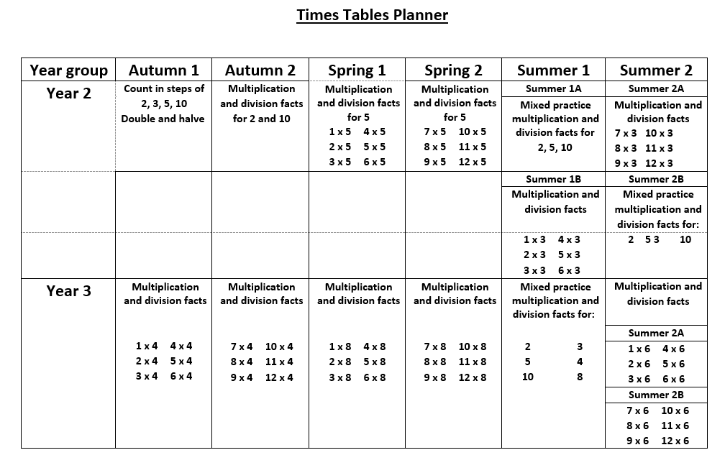
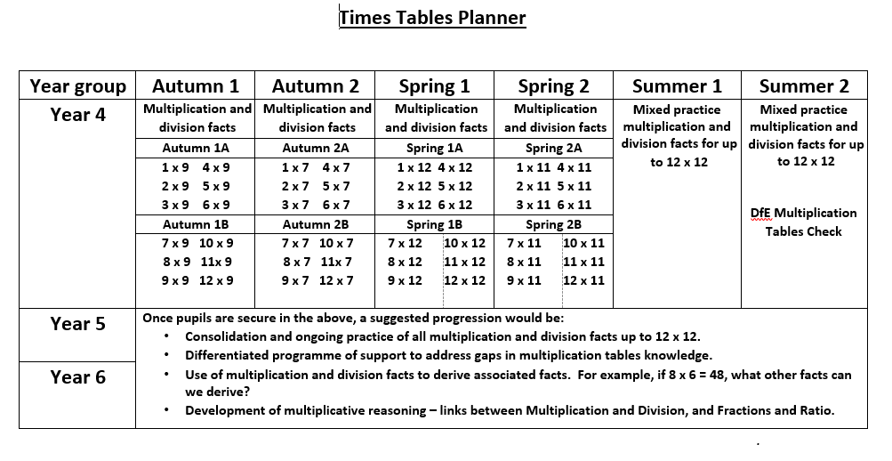

Structure of the maths lesson
Reasoning – weaving throughout each step

TEACH | TRY | APPLY
- Quality first teaching  - Modelling mathematic concepts  - Use of concrete and practical resources to model concepts  - Working walls to scaffold and support understanding  - Vocabulary development  - Challenge built to to extend and deepen understanding | - Opportunities are given to try and practise a mathematical skills (short opportunities not pages and pages of calculations)  - Differentiated inputs (use where necessary to address an area of need or with specific pupils)  - Resources for fluency | - Opportunities to apply concepts to real life contexts (e.g. negative numbers to temperature and thermometers)  - Opportunities for pupils to use different mathematical skills in alternative contexts (e.g. use of rounding numbers when estimating money using £ and p)  - Application and reasoning activities to be used to demonstrate a ‘deep’ understanding
Resources that may be used:
- White Rose materials
- Target Your Maths
- NRICH
- NCETM
- Deepen your Understanding
- Classroom Secrets
- Convince Me Cards
- Test Base materials
- PIXL materials

A ‘Review and Do’ activity often is used to start the maths lesson to aid with retention of knowledge as the beginning of each session. This is a key focus of Leading Learners as we want pupils to make connections to previous learning and help them know more and remember more.
Teachers are encourage to deliver lessons using the ‘Teach, Try and Apply’ principles where teachers model mathematical concepts using a variety of resources and reinforce the development of age appropriate mathematical language.
Teach, Model & Scaffold- Explicit teaching and modelling (Examples: Use of interactive whiteboard, concrete resources, pictorial representations and abstract as appropriate)
Try/Practise – this could be independent on whiteboards or jotters, partner talk, and may include using resources.
Apply- Independent activity including fluency, reasoning and problem solving.
Consolidate- Reasoning or problem-solving question to end every maths lesson (whole class) and interwoven through this whole process.
Fluency is a fundamental of mathematics, ensuring that pupils have conceptual understanding and are able to recall and apply their knowledge rapidly and accurately.
As well as factual fluency, children become confident in the two other types of fluency:
Conceptual fluency, ‘I know why..’, e.g. exploring the five strands of place value, (counting, recognition of cardinal numbers, knowing what each digit in a number represents, understanding our base-10 structure and exchanging), what an equivalent fraction is and identifying key features of different representations of data.
Procedural fluency, ‘I know how..’ e.g. +- x ÷ calculation methods linked to whole numbers, fractions and decimals and exploring step by step mental and written methods.
Children are given regular opportunities to recall known facts, develop number sense, know why they are doing what they are doing and know when it is appropriate and efficient to choose different methods and will apply skills to multiple contexts e.g. multiplying and dividing by 10 to convert units of measurements.
Reasoning and problem solving is planned and interwoven into the mathematics curriculum.
Reasoning questions are explicitly taught and modelled through the use of discussion, maths partner talk, manipulatives and written work using ‘stem sentences’ which develop the language of reasoning. Reasoning activities could include ‘spot the mistake’, ‘alike and different’, ‘odd one out’, ‘always, sometimes and never’ and ‘true and false’ type activities.
Vocabulary and mathematical language
The quality and variety of language that pupils hear and speak are key factors in developing their mathematical vocabulary and presenting a mathematical justification, argument or proof. We support children to use precise mathematical vocabulary and to express their mathematical thinking in complete sentences. Language will be carefully planned and chosen to allow children to develop their mathematical language. All staff model the use of this language consistently. Sentence stems that will allow the development of the language of reasoning, ‘Convince me that…’ etc are used throughout school. The acquisition of this language of reasoning begins in Early Years and continues throughout school. Key Stage One pupils are encourage to reasoning orally with adults recording that snapshot of reasoning regularly in books. Key Stage Two pupils are encourage to write an explanation of their reasoning using scaffolds and supports such as the sentence stems and PEE (Point, Evidence and Explanation).
Usefulness of Maths for their Future
Mathematics is an essential life skill and is needed by the children in all stages of their school life and beyond. Our curriculum offer allows pupils the opportunity to make links with employability skills and how maths can be used in a variety of different jobs that they may wish to pursue in the future. The STEM materials and PIXL materials on ‘Futures’ career related learning, are used to deliver opportunities to discuss employability skills needed for their future.
Calculation Skills for the Four Operations
As well as the acquisition of key number facts within each year group, the importance of being able to choose an efficient calculation method is also taught throughout school. The White Rose Maths Calculation guidance for addition and subtraction and multiplication and division is listed below.
Calculation policy and Reception Guidance on Early Number
Progression maps Nursery & Reception and Years 1 – 6
Ready to Progress criteria mapping
Assessment Grids including Pre-Key Stage Guidance statements
Impact
Our well-planned Maths curriculum ensures that children are fluent and confident mathematicians, who exude an enjoyment and curiosity about the subject. Our children are enthusiastic and competent mathematical problem solvers, within maths lessons and across the curriculum. Children perform consistently well in Mathematics and are very well prepared for the next stage in their education.
We gather this evidence through a variety of scrutiny: pupil voice, lesson visits and pupil outcomes in books. We use summative assessment data from statutory tests, End of Year assessments – SATs, Multiplication Times Table Check data for Year 4 and Pixl termly in-year tests as well as on-going teacher assessment to make judgments about attainment and progress within the maths curriculum.

