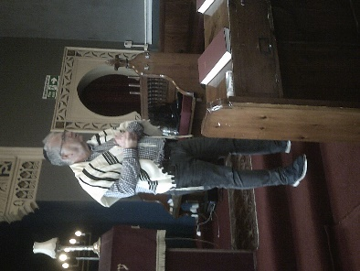
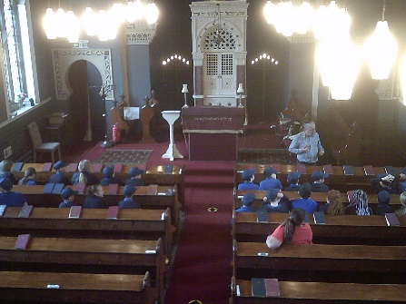
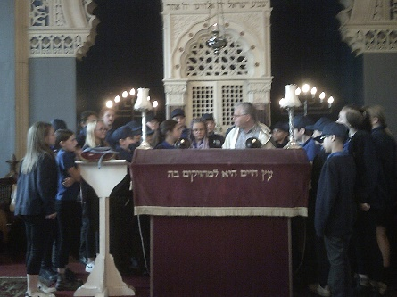
Thursday 9th June 2022

As part of their R.E. lessons, Year 6 had the opportunity to visit a synagogue in Bradford. They listened to Holy music and were able to look at the Torah Scroll as it was read in Hebrew.
After listening to the history of the building, and admiring the architecture and beautiful symmetrical stain glass windows, they had time exploring the building themselves.
The children concluded their visit by asking a range of interesting questions to further their understanding of the faith and the people who practise it in our area.

