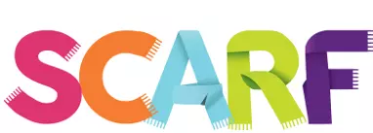

SCARF: Safety, Caring, Achievement, Resilience, Friendship
Coram Life Education & SCARF is the UK's leading charity provider of PSHE and wellbeing education in primary schools.
Our SCARF resources are developed by teachers for teachers. Over 50,000 subscribe to SCARF as their chosen provider of PSHE. Here are a few reasons why:
- A Whole-school approach to health and wellbeing
- Fully-resourced, comprehensive PSHE programme - over 360 lesson plans
- Online - always up to date
- Fulfils all DfE statutory requirements for Relationships & Health Education
- Half term units of work & planning from Nursery to Year 6
- Ofsted Audit tool meeting expectations for Intent, Implementation and Impact through the SCARF coherent, sequential curriculum
- Assessment tools & progression embedded
- Comprehensive free staff SCARF training
- Access to free and low-cost specialist training
- Support of a SCARF co-ordinator
SCARF's whole-school approach supports primary schools in promoting positive behaviour, mental health, wellbeing, resilience and achievement – giving you everything you need to meet the DfE RSHE statutory requirements. More than just a PSHE scheme of work, SCARF supports great learning every day

