Promoting the 9 characteristics of equality at Worth Valley Primary School.

We work to ensure that our children understand that:
There are no outsiders at Worth Valley
Everyone is different
We celebrate our differences
We are all equal.
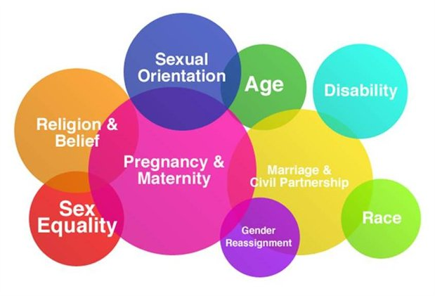
At Worth Valley Primary School we strongly support the nine protected characteristics defined in the Equality Act 2010 in all aspects of school life, from our recruitment of staff, the design of our curriculum, our school values and how we support our vulnerable families. We are proud to be a Resourced Primary School where children with disabilities and special education needs are fully included in all of our school life. The national curriculum recognises how important it is for children to understand the world in which they live. They want children to live alongside and show respect for a diverse range of people. A way in which schools can ensure they are providing children with the knowledge and skills to do this is through the teaching of protected characteristics.
It is extremely important for us to enrich our pupils with age appropriate knowledge and grow to be respectful, ambitious and empathetic pupils who respect the world in which they live. We foster a culture that empowers children to challenge their misconceptions and build their knowledge on those around them. Children are naturally curious and may feel anxious about sharing their experiences. At Worth Valley we build a culture with a notion of allowing children and staff to be themselves.
The 9 protected characteristics are:
- Age
- Disability
- Gender reassignment
- Marriage and civil partnership
- Pregnancy and maternity
- Race
- Religion or belief
- Sex
- Sexual orientation
The government does stress that not all of these characteristics have to be taught about in every year group and schools should use their professional judgement to plan their curriculum appropriately. Here at Worth Valley, our PSHE/RSE lessons are taught using the National Curriculum guidance and the SCARF curriculum. These are used in addition to various other ways we teach respect and diversity across school for example through literacy, assemblies, groups and sporting activities.

