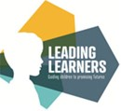

Spring 2

What are we learning in Reception?

Key texts and topics.

We’ve got another busy half term ahead of us!

Our topic this term is Maps and mapping. We will be reading lots of fantastic stories involving journeys and interesting landmarks that we can create maps and story maps of. Here’s some of the texts we’ll be sharing…

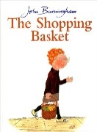 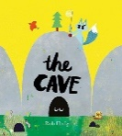 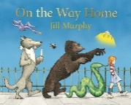

Communication and Language

We will be continuing to learn new words through the stories and discussions we have with the aim of learning to:

Ask a variety of questions

Tell others about their thoughts, feelings and opinions

Listen and respond to others appropriately

Apply new words in every day conversations

Physical Development

Through our outdoor provision and hall time we will be learning new games and action rhymes and developing our skills using tools and equipement. We will be continuing our work on balance and coordination and basic ball skills and control.

In preparation for writing we will be practising our letter formation, you can do this at home using the formation rhymes sent home previously to help.

P.S.E.D. and 

We will continue our work on being independent, following routines and instructions.

We’ll also be talking about caring for ourselves, our family and friends and our world.

SCARF – Rights and respect

* Looking after money
* Looking after my special people
* Being helpful at home
* Caring for our classroom

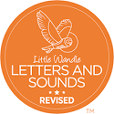

We will be continuing our Phase 3 work consolidating our knowledge of digraphs and trigraphs and learning to read longer words.

Please keep practising tricky words at home-

I, go, to, the, no, is, into, he, has, she, as, her, we, be, me, my, they, all, are, was, you, sure, pure

Expressive Arts and Design   
We will be continuing our work around looking as we develop our skills in observational drawing and painting. We will be imitating the work of David Hockney as we recreate his spring flowers work using an ipad.

We have recently started our own Drawing Club. Every child takes part every day. We learn new words and actions and retell stories by drawing our ideas.

Maths  
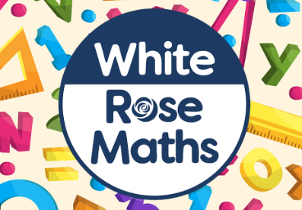

We will be working with numbers 5 – 10 to explore doubles, composition, addition and 1 more/less. We will be continuing our work on subitising, and different arrangements and ways to help us represent our ideas.

We’ll also be looking at length, height, time and 3D shapes.

Understanding the World

We’ll be finding out about lifecycles of chickens and hopefully we’ll get watch an egg hatch! We will also be observing the changes that take place in frogspawn and the hatching of tadpoles and their journey to becoming a frog.

We will be finding out about about different vehicles and machines and mechanisms and choosing the right tool for the right job.

We will be exploring our local area and creating simple maps of where we live.

Later in the term we will be looking for signs of spring and find out about Easter.

How you can help your child at home

Please read at home and sign your child’s reading journal so we can add your efforts at home to our reading championship. We are trying to develop the children’s fluency in reading so please when reading at home encourage them to read each sentence fluently (after they have decoded the words).

Practise the new sounds and tricky words we send home each week.

Count- forwards and backwards, count the stairs as you walk up them or the bricks your child has used to make a tower. You could also ask your child how many there’d be if we got 1 more or how many if we take one away.

Encourage your child to be independent and to look after their things at school. It would also be a huge help if you could label their uniform with their name. Thank you for your support.