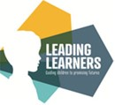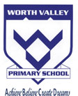

Spring 1   
What are we learning in Year 1?

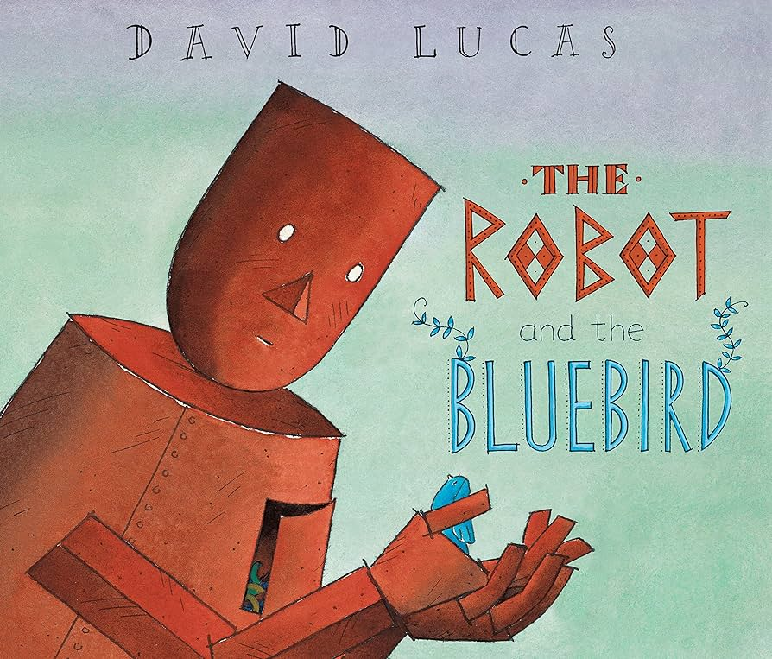

English  
We have been focusing on the lovely story – The Robot and the bluebird!

We have really enjoyed writing about the characters and creating our own robot!

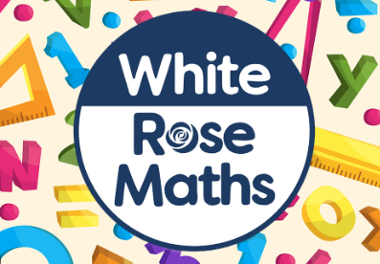Maths  
Our focus in maths this half term has been place value (to 50), length and height and mass and volume!

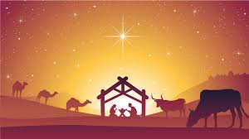  
Religious Education  
We are going to be learning about Easter!

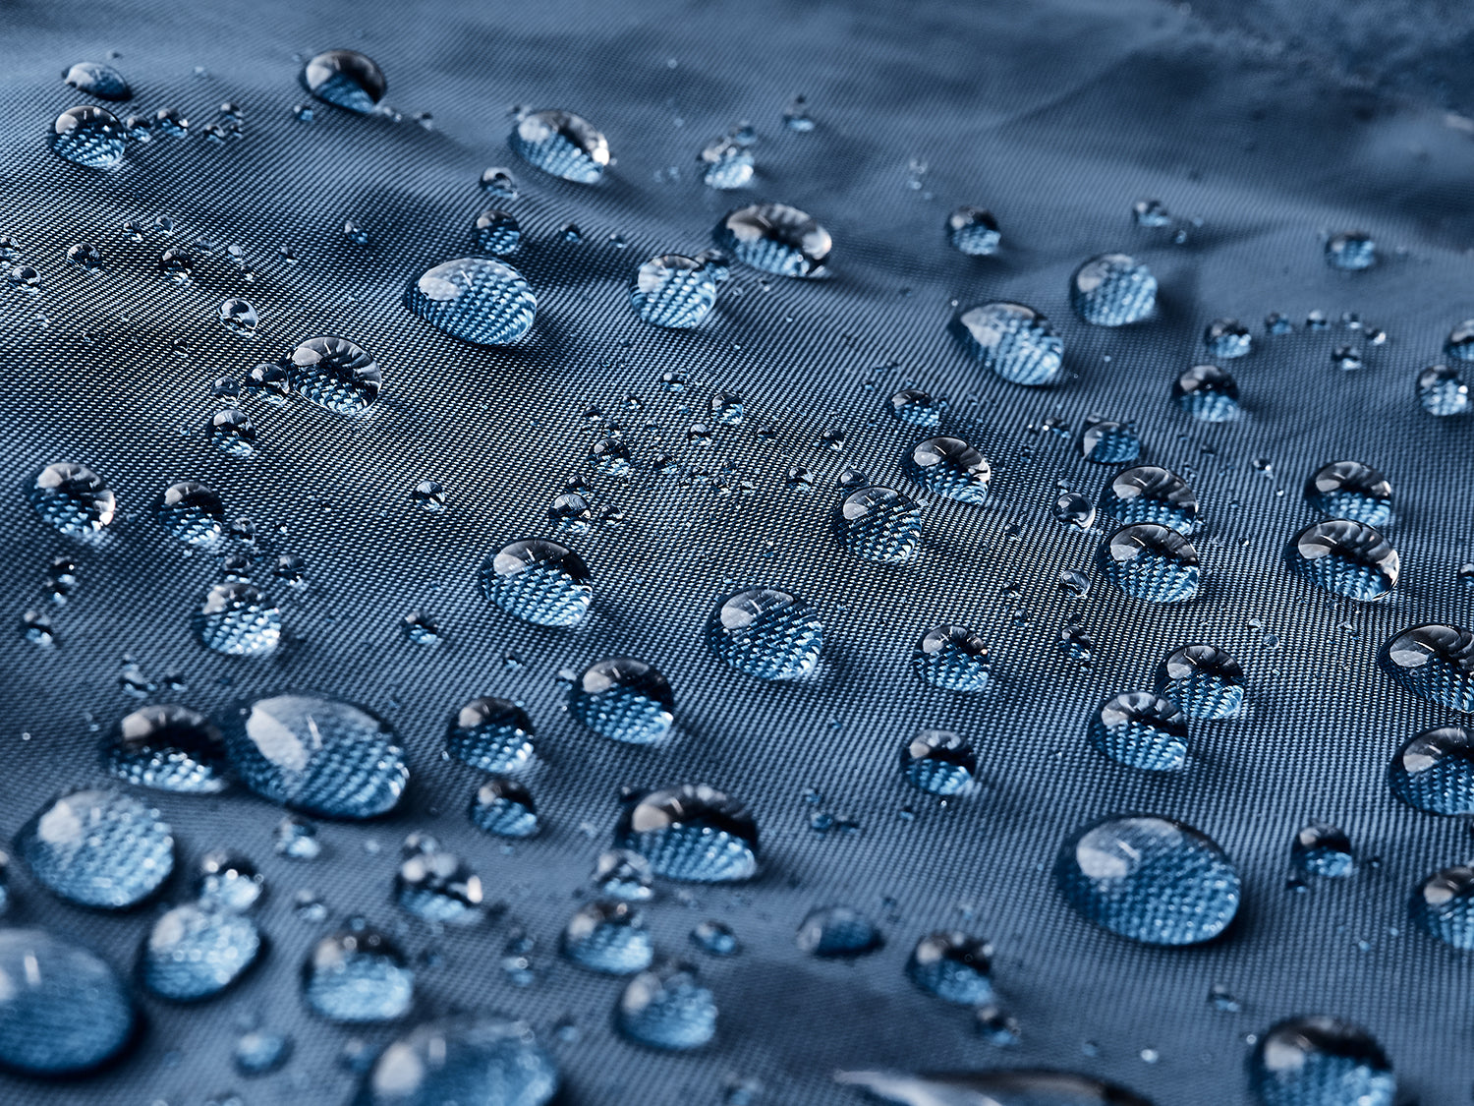

Science

In science we have been learning about materials! We have been building our own house making sure that it is waterproof, strong, windproof with transparent windows and an opaque door!

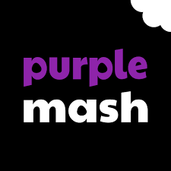Computing

We have been learning about technology inside and outside of school and we have been creating our own animated story books.

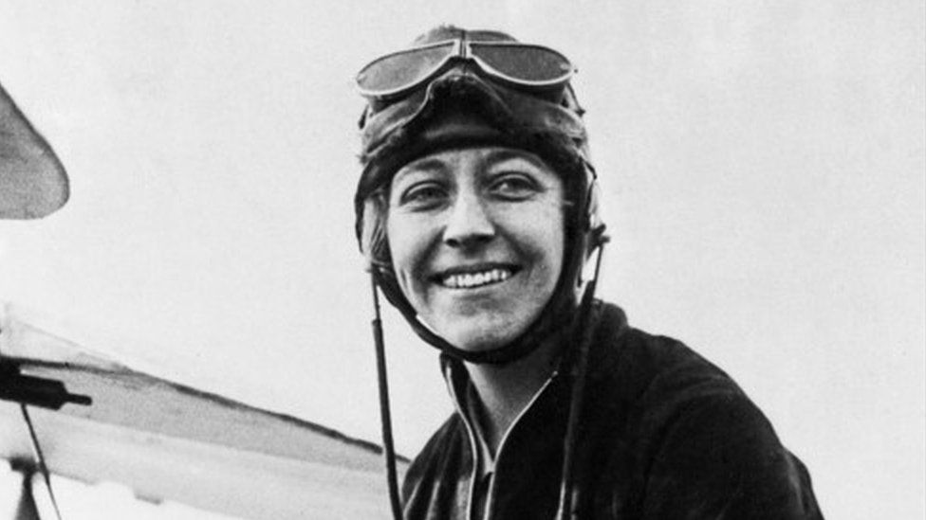

History  
We are learning about the inspiring Amy Johnson who was the first female to fly solo to Australia!

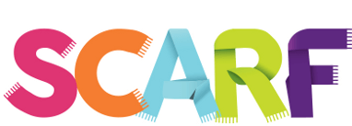  
PSHE  
We are learning about rights and respect!